Chapter 4 AC circuit

1. Given the sinusoidal voltage $\text{v(t)=50}\text{cos}\left(30t+{10}^{∘}\right)V$ find: (a) the amplitude Vm, (b) the period T, (c) the frequency f.
2. Express the following functions in cosine form:

(1) $10\text{sin}(ωt+{30}^{∘})$

(2) $-20\text{sin}(ωt+{45}^{∘})$

1. For the following a pair of sinusoid, determine which one leads and by how much.
$$v_{1}\left(t\right)=4\text{cos}\left(377t+{10}^{∘}\right),$$

$$v_{2}(t)=-20\text{cos}377t$$

2. Find current i in the circuit of Fig.4-1, when $v_{s}(t)=50\text{cos}200t$ V.

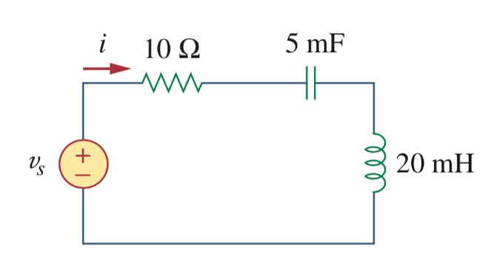

Figure 4-1

1. Calculate the capacitor voltage for t < 0 and t > 0 in Figure 4-2.

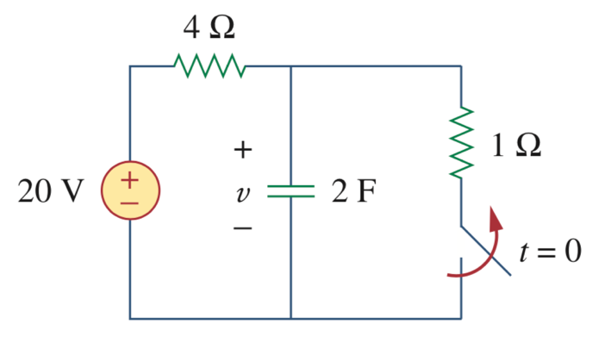

Figure 4-2